Authorization Middleware

📝Definition
# Source: AI Source: Provided by: [Data Path: Persons Table -> ID Column: 1, Name_En Column: Motasem Essam] -> From: [ChatGPT] on [1/23/2026]
Authorization Middleware determines what an authenticated user is allowed to do.
👉 It answers the question: “Are you allowed to perform this action?”

🔑 Key Responsibilities
# Source: AI Source: Provided by: [Data Path: Persons Table -> ID Column: 1, Name_En Column: Motasem Essam] -> From: [ChatGPT] on [1/23/2026]
- Check permissions or roles of the user
- Block users from accessing forbidden resources
- Enforce access control policies
- Keep business logic secure and consistent

🔄 How It Works in Flow
# Source: AI Source: Provided by: [Data Path: Persons Table -> ID Column: 1, Name_En Column: Motasem Essam] -> From: [ChatGPT] on [1/23/2026]
Client → Request → Authentication Middleware → Authorization Middleware → Controller
- User must first be authenticated ✅
- Authorization checks whether user can perform the action
- If not allowed → 403 Forbidden ❌

🧱 Examples

1️⃣ Role-Based Authorization (Laravel)
# Source: AI Source: Provided by: [Data Path: Persons Table -> ID Column: 1, Name_En Column: Motasem Essam] -> From: [ChatGPT] on [1/23/2026]
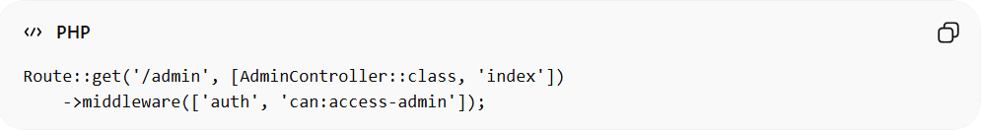
Route::get('/admin', [AdminController::class, 'index'])
->middleware(['auth', 'can:access-admin']);
- auth → ensures user is logged in
- can:access-admin → checks if user has permission

2️⃣ Custom Authorization Middleware
# Source: AI Source: Provided by: [Data Path: Persons Table -> ID Column: 1, Name_En Column: Motasem Essam] -> From: [ChatGPT] on [1/23/2026]
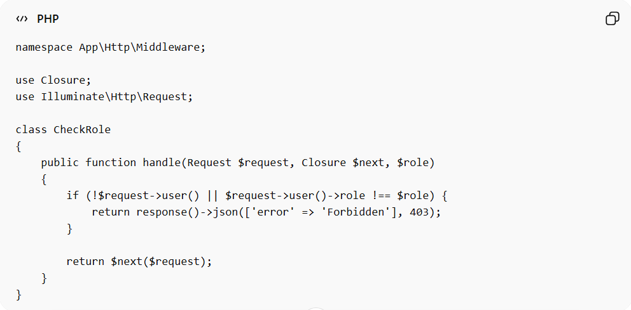
namespace App\Http\Middleware;

use Closure;
use Illuminate\Http\Request;

class CheckRole
{
public function handle(Request $request, Closure $next, $role)
{
if (!$request->user() || $request->user()->role !== $role) {
return response()->json(['error' => 'Forbidden'], 403);
}

return $next($request);
}
}
Usage:
Route::get('/admin', [AdminController::class, 'index'])
->middleware('check.role:admin');

3️⃣ Policy-Based Authorization (Laravel)
# Source: AI Source: Provided by: [Data Path: Persons Table -> ID Column: 1, Name_En Column: Motasem Essam] -> From: [ChatGPT] on [1/23/2026]
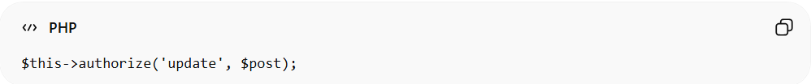
$this->authorize('update', $post);
- Checks if user can update a specific resource
- Keeps rules centralized in Policy classes

❌ Bad Example (No Middleware)
# Source: AI Source: Provided by: [Data Path: Persons Table -> ID Column: 1, Name_En Column: Motasem Essam] -> From: [ChatGPT] on [1/23/2026]
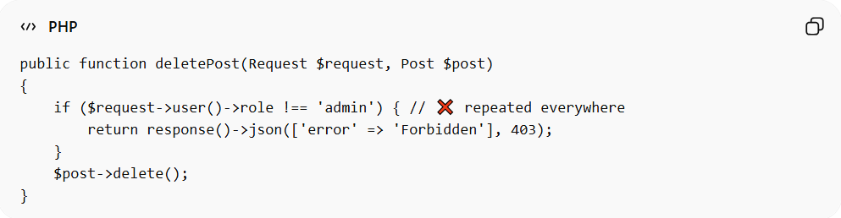
public function deletePost(Request $request, Post $post)
{
if ($request->user()->role !== 'admin') { // ❌ repeated everywhere
return response()->json(['error' => 'Forbidden'], 403);
}
$post->delete();
}
Problems:
- Repeated authorization logic ❌
- Hard to maintain ❌
- Violates DRY ❌

✅ Good Example (Using Middleware)
# Source: AI Source: Provided by: [Data Path: Persons Table -> ID Column: 1, Name_En Column: Motasem Essam] -> From: [ChatGPT] on [1/23/2026]
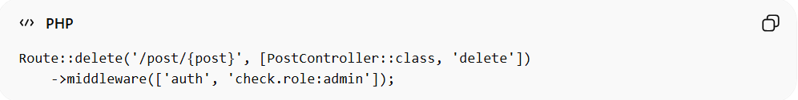
Route::delete('/post/{post}', [PostController::class, 'delete'])
->middleware(['auth', 'check.role:admin']);
- Centralized access control ✅
- Clean controller ✅
- Easy to reuse ✅

🔄 Authentication vs Authorization
# Source: AI Source: Provided by: [Data Path: Persons Table -> ID Column: 1, Name_En Column: Motasem Essam] -> From: [ChatGPT] on [1/23/2026]
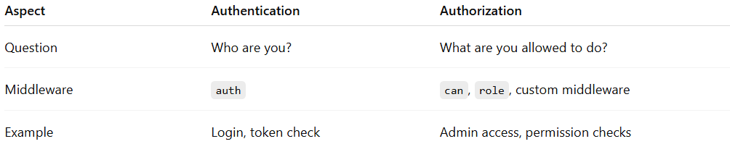
Aspect | Authentication | Authorization
Question | Who are you? | What are you allowed to do?
Middleware | auth | can, role, custom middleware
Example | Login, token check | Admin access, permission checks

⚠️ Common Mistakes
# Source: AI Source: Provided by: [Data Path: Persons Table -> ID Column: 1, Name_En Column: Motasem Essam] -> From: [ChatGPT] on [1/23/2026]
- Checking authorization inside controller instead of middleware ❌
- Confusing authorization with authentication ❌
- Hardcoding permissions instead of using policies or roles ❌

💡 Key Idea
# Source: AI Source: Provided by: [Data Path: Persons Table -> ID Column: 1, Name_En Column: Motasem Essam] -> From: [ChatGPT] on [1/23/2026]
Authorization Middleware enforces access rules, ensuring that only permitted users can perform actions, keeping your application secure.

🧾 Summary
# Source: AI Source: Provided by: [Data Path: Persons Table -> ID Column: 1, Name_En Column: Motasem Essam] -> From: [ChatGPT] on [1/23/2026]
- Runs after authentication
- Checks permissions or roles
- Blocks unauthorized actions
- Keeps controllers clean and maintainable

